**Umut Genlik CS 422 Homework 2**

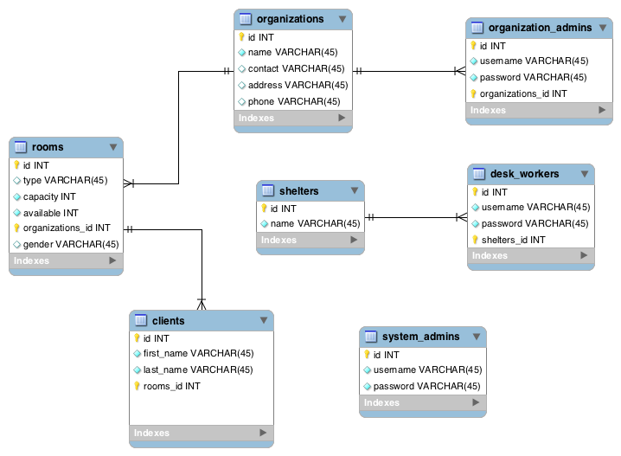

I entered sufficient amount data to produce a vacancy report. I created a view to display this vacancy report. It is up and running on bigyellowcat server. Here is a sample report:

**Database:** alti  **Generation Time:** Oct 05, 2009 at 08:00 AM  **Generated by:** phpMyAdmin 3.2.2 / MySQL 5.0.51a  **SQL query:** SELECT * FROM `vacancy_report` LIMIT 0, 30 ;  **Rows:** 6

|  |  |  |  |  |  |  |  |
| --- | --- | --- | --- | --- | --- | --- | --- |
| **Organization** | **contact** | **address** | **phone** | **type** | **capacity** | **available** | **gender** |
| An Organization | Cenk Alti | 4400 Vestal Parkway E | 5555555 | Dormitory | 20 | 13 | Adult (Men) |
| An Organization | Cenk Alti | 4400 Vestal Parkway E | 5555555 | Dormitory | 20 | 10 | Adult (Women) |
| another org. | John Doe | 555 faraway | 7654321 | Rooms (Single) | 10 | 5 | Adult (Men) |
| YWCA | Jane Smith | 123 somewhere | 1234567 | Rooms (double) | 12 | 9 |  |
| YWCA | Jane Smith | 123 somewhere | 1234567 | Dormitory | 16 | 8 | Adult Men |
| YWCA | Jane Smith | 123 somewhere | 1234567 | Rooms (single) | 6 | 3 | Adult Women |

**Entities**

**Organization**: This table contains data of non-profit organizations which supply shelters for people.

**Room**: This table contains data of the room that belongs to a particular organization.

**System** **Admin**: This table represents a system administrator. He will have privilege to create and manage organizations.

**Organization** **Admin**: This table represents a organization admin. He is going to manage particular organization.

**Shelter**: This table contains data of dormitories and romms for people to stay.

**Desk** **Worker**: This table represents a basic user of the system. He is going to see vacancies and make reservations for clients.

**Client**: Client is the people who needs bed.

**Attributes and Relations**

Relations(foreign keys) are underlined.

**System Admin**

**Id**: primary key, int, auto increment

**Username**: login name of the administrator, varchar(45), unique

**Password**: password of the admin, varchar(45)

**Organizations Table**

**id**: primary key of organization, int, auto increment

**name**: name of the organization, unique, varchar(45)

**contact**: contact person of the organization, varchar(45)

**address**: address of the organization, varchar(45)

**phone**: phone of the organization, varchar(45)

**Organization Admins Table**

**Id**: primary key of the admin, int, auto increment

**Username**: login name of the admin, varchar(45)

**Password**: password of the user, varchar(45)

**Organization_id:** id of the organization which this person administer

**Rooms Table**

**Id:** primary key, int, auto increment

**Type**: type of the room, varchar(45)

**Capacity**: capacity of the room, int

**Available**: number of available beds, int

**Gender**: gender of the people residing in the room, varchar(45)

**Organization_id:** the organization which this room belongs to

**Clients Table**

**Id**: primary key, int, auto increment

**First**_**name**: first name of the person

**Last**_**name**: last name of the client

**Room_id:** id of the room which the client is staying

**Shelters Table**

**Id**: primary key, int, auto increment

**Name**: name of the shelter

**Desk Workers Table**

**Id**: primary key, int, auto increment

**Username**: login name of the desk worker, varchar (45)

**Password**: password of the desk worker, varchar(45), unique

**Shelter_id**: the shelter which this desk worker is working for